Project Initiation and Understanding
Project: Hospital Outpatient Appointment Optimisation
System
Project By: Ume Laila Batool
Date: March 2026
Graduate Data Analyst

Table of Contents
Contents
1. Introduction: 3
1.1 Purpose 3
1.2 Project overview 3
1.3 Scope of the Document 3
2. Problem Statement 3
3. Business Objectives 4
3.1 Reduced Missed Appointments (DNA) 4
3.2 Reduce Patient Waiting Times 4
3.3 Improve Clinic Utilisation 4
3.4 Improve operational Efficiency 4
4. Stakeholder Identification 5
4.1 Clinical Stakeholders 5
4.2 Operational Stakeholders 5
4.3 Management Stakeholders 5
4.4 Technical Stakeholders 6
4.5 Governance and Compliance Stakeholders 6
4.6 External Stakeholders 6
5. Stakeholder Matrix 6
6. Project Scope 7
7. Business Case Summary 8

Introduction:

Purpose
This document provides a structured analysis and requirement specification for the development of a hospital outpatient appointment optimisation system. The purpose of this document is to identify the current challenges within the outpatient appointment scheduling process and propose a digital solution to improve operational efficiency, reduce missed appointment, and enhance patient experience.
The document outlines the project objectives, stakeholder analysis, current–processes, future-state improvements, and system requirements required to support the implementation of the proposed solution.

1.2 Project overview
Hospitals frequently face challenges managing outpatient appointments efficiently due to high patient demand, manual administrative processes, and limited visibility of clinic capacity. In the current system, a significant number of appointments result in “Did Not Attend” (DNA) cases, leading to wasted clinical time and extended waiting lists for patients.

Scope of the Document
This document focuses on the analysis and design of a digital outpatient appointment management system. It includes business objectives, stakeholder identification, current and future process analysis, functional and non-functional system requirements, and key performance indicators for monitoring operational improvements.
  - intended stakeholders
This document is intended for stakeholders involved in the planning, development, and implementation of the outpatient appointment optimisation system. These include:
- Hospital Management
- Operational Staff
- IT Teams
- System Developers
- Project stakeholders responsible for approving and delivering the solution

Problem Statement
The hospital outpatient department is currently experiencing operational insufficiencies in managing patient appointment. A significant proportion of scheduled appointments result in patients not attending their appointments, commonly referred to as “Did Not Attend” (DNA). The current DNA rate is approximately 28%, which leads to underutilised clinical capacity, wasted resources and delays in patient care.
In addition, the current appointment reschedule process is largely manual and time-consuming for administrative staff. This creates delays in reallocating cancelled appointments slots and contributes to longer waiting times for patient seeking outpatient services.
The lack of real-time performance monitoring and reporting tools also limits the hospitals’ ability to identify scheduling insufficiencies and optimise clinic utilisation.
As a result, patients experience extended waiting times, averaging approximately 10 weeks for outpatient appointments, which negatively impacts patient satisfaction and access to timely healthcare services.

Business Objectives
The objective of this project it to improve the efficiency and effectiveness of the hospitals’ outpatient appointment management process. By implementing a digital optimisation system, the hospital aims to reduce missed appointments, improve clinic utilisation, and enhance the overall patient experience.
The key business objectives of this project are outlines below:

3.1 Reduced Missed Appointments (DNA)
Reduce the outpatient Did Not Atten (DNA) rate from 28% to 10% within 6 months of implementing the new appointment management system. This will help maximise clinical capacity and reduce wasted appointment slots.

3.2 Reduce Patient Waiting Times
Decrease the average outpatient waiting time from 10 weeks to 6 weeks within nine months of system implementation. This will improve patient access to care and reduce delays in treatment.

3.3 Improve Clinic Utilisation
Increase clinic utilisation tares from 65% to 85% within six months by optimising appointment scheduling and improving the reallocation of cancelled appointment slots.

3.4 Improve operational Efficiency
Reduce the administrative workload associated with manual appointment scheduling and rescheduling by 40% within three months of system implementation.

Stakeholder Identification
For the implementation of the Hospitals Outpatient Appointment Optimisation System, stakeholders have been categorised based on their roles and level of involvement I outpatient service delivery process.

Clinical Stakeholders
Clinical Stakeholders are responsible for delivering patient care and rely on efficient scheduling systems to manage patient appointments effectively:
These stakeholders include:
- Doctors/ Consultants
- Nurses
- Healthcare Assistants
The stakeholders depend on a well-managed appointment system to ensure clinics run efficiently and that patient consultations are conducted without unnecessary delays.

Operational Stakeholders
Operational stakeholders are responsible for the day-today administration and coordination of outpatient appointments.
These include:
- Outpatient Administrators
- Reception Staff
- Clinic Coordinators
These stakeholders will be the primary users of the system and will interact with the scheduling platform to book, cancel, and reschedule patient outcomes.

4.3 Management Stakeholders
Management stakeholders oversee hospital operations are responsible for ensuring efficient resource utilisation and service delivery.
These Stakeholders include:
- Hospital Operations Manager
- Head of Outpatients
- Executive Sponsor
They will reply on performance dashboards and reports generated by the system to monitor clinic utilisation, waiting times, and missed appointments.

4.4 Technical Stakeholders
Technical stakeholders are responsible for implementing, maintaining, and supporting the digital solution.
These include:
- IT Department
- System Architect
- Data/ Business Intelligence Team
They will ensure the system integrates with existing hospitals infrastructure and supports data reporting requirements.

4.5 Governance and Compliance Stakeholders
Governance stakeholders ensure that the system complies with regulatory, security and data protection standards.
These include:
- Data Protection Officers
- Information Governance Team
- Compliance officers
Their sole is to ensure that patient data is handled securely and in accordance with legal requirements.

4.6 External Stakeholders
External stakeholders include individuals who interact with the hospital but are not part of the organisation’s internal structure.
These include:
- Patients
Patients are key stakeholders as the system directly affects their ability to book, attend and manage their appointments.

Stakeholder Matrix
This classification helps determine the level of engagement required throughout the project lifecycles.
High Power – High Interest (Manage Closely)
These Stakeholders have significant influence over project decisions and are highly invested in the project’s success.
- Executive Sponsor
- Hospital Operations Manager
- Head of Outpatients
- IT/ Systems Architect
These stakeholders require regular updates and active engagement throughput the project.
High Power – Low Interest
These Stakeholders have influence over the project but are not involved in day-to-day project activities.
- Hospital Board
- Regular Authorities
These stakeholders should be kept informed of major project developments and milestones.
Low Power – High Interest
These stakeholders will be directly impacted by the system and will interact with it regularly.
- Doctors
- Nurses
- Administrators
- Reception Staff
- Patients
They should receive regular communication regarding project progress and system changes.
Low Power - Low Interest
These stakeholders are not heavily involved but may be indirectly affected by the system.
- Other hospital departments not directly involved in outpatient scheduling
They require minimal communication but should still be monitored.

Project Scope
The following components are included within the scope of this project:
- Development of a digital outpatient appointment management system
- Appointment scheduling and booking functionality
- Appointment cancellation and rescheduling capabilities
- Automated patient reminders via SMS or email
- Waiting list management for cancelled appointment slots
- Dashboard for monitoring clinic performance and operational metrics
- Tracking and reporting of Did Not Attend (DNA) rates

Business Case Summary
The hospital outpatient department currently experiences a high rate of missed appointments and extended waiting times for patients. These issues result in inefficient use of clinical resources and reduced patient satisfaction.
Implementing a digital appointment optimisation system will allow the hospital to automate key administrative processes, improve appointment management, and provide real – time insights into clinic performance.
The introduction of automated reminders, improved scheduling capabilities and performance dashboards will help reduce missed appointments, optimise clinic utilisation, and improve access to care for patients.
Ultimately, the proposed solution will support operational efficiency, improve service delivery, and enhance the overall patient experience.

Current State analysis

As-Is Process Overview
The current outpatient appointments scheduling process is largely manual and involves multiple administrative steps. The process requires coordination between administrative staff, clinicians, and patients, which can result in delays, scheduling conflicts, and missed appointments.

As is process: Outpatient Appointment Scheduling
Step 1 – Patient Referral
A patient is referred to the outpatient department by a general practitioner (GP) or another healthcare professional.
Step 2 – Referral Received by Hospital
The hospital receives the referral through email, referral systems, or manual documentation.
Step 3 – Referral Reviewed
An outpatient administrator reviews the referral and assigns the patient to the appropriate clinic or consultant.
Step 4 – Appointment Slot Search
The administrator checks the scheduling system to identify available appointment slots for the relevant clinic.
This may involve manually reviewing calendars and clinic availability.
Step 5 - Appointment Booking
The administrator schedules the appointment and records the patient details in the appointment system.
Step 6 – Appointment Notification
The patient is informed of their appointment via letter, email, or phone call.
Step 7 – Patient Waits for Appointment
The patient waits for the scheduled appointment date, which may be several weeks away depending on clinic availability.
Step 8 – Appointment Day
On the day of appointment, the patient attends the clinic and checks in with reception.
Step 9 – Missed Appointment (DNA)
If a patient does not attend the appointment and does not inform the hospital in advance, the appointment is recorded as a Did Not Attend (DNA).
Step 10 – Rescheduling
If a patient cancels or misses an appointment, administrative staff must manually contact the patient to arrange a new appointment slot.

Current Process Pain Points
The current process presents several operational challenges:
High DNA Rates
Patients may forget their appointment due to the lack of automated reminders.
Manual Scheduling
Administrators must manually search for available appointments slots, which can be time-consuming.
Inefficient Rescheduling
Cancelled appointments are not always filled quickly, resulting in unused clinic capacity.
Limited Visibility
Hospital management has limited access to real-time data regarding appointment performance, clinic utilisation, and waiting times.

8.4 Process Map
Below is a process map

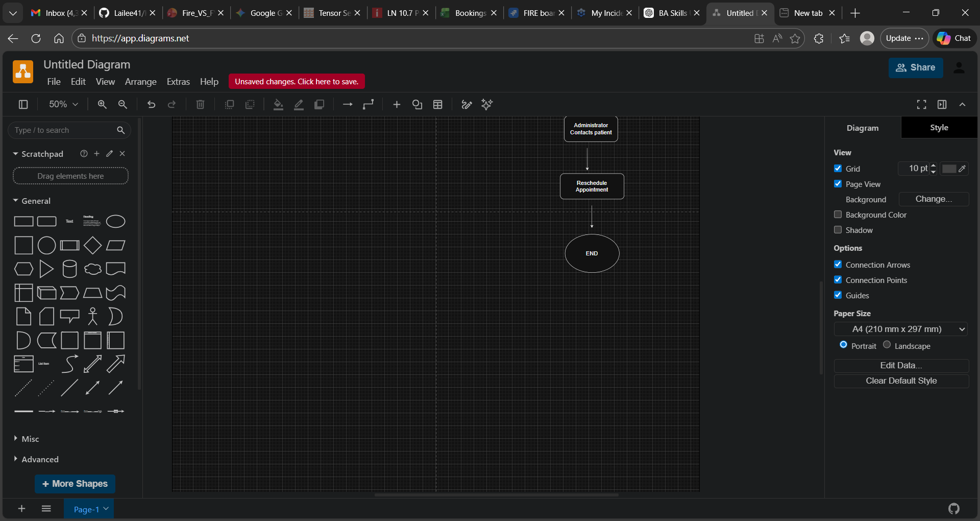
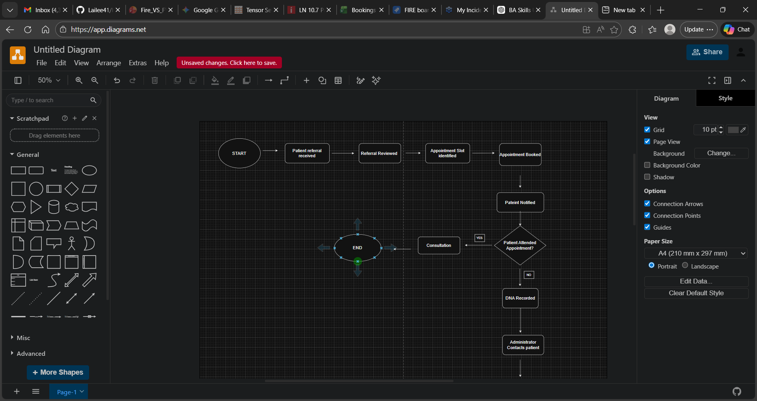

Root Cause Analysis
Root Cause Analysis was conducted to identify the underlying factors contributing to the high rate of missed outpatient appointments and long patient waiting times. The 5-way technique was used to investigate the primary causes of these issues within the current outpatient appointment scheduling process.

High Did Not Attend (DNA) Rate
Problem
The outpatient department currently experiences a 28% Did Not Attend (DNA) rate, resulting in wasted clinical capacity and delays in patient care.
Why 1
Patients forget their scheduled appointments.
Why 2
Patients are not consistently reminded about their upcoming appointments.
Why 3
The current system does not provide automated reminder notifications to patients.
Why 4
Patient communication relies on manual notifications such as letters or phone calls.
Root Cause
The hospital lacks an automated patient notification system that reminds patients of their upcoming appointments.

Long Waiting Times for Appointments
Problem
Patients wait an average of 10 weeks for outpatients’ appointments.
Why 1
Appointments slots are not always filled efficiently.
Why 2
Cancelled appointments are not quickly reallocated to other patients.
Why 3
Administrators must manually identify available slots and contact patients.
Why 4
The current system does not support automated waiting list management.
Root cause
The hospital lacks a digital scheduling system capable of automatically reallocating cancelled appointments.
  - Administrative workload
Problem
Administrative staff spend significant time managing appointment scheduling and rescheduling.
Why 1
Appointment management processes are largely manual.
Why 2
Administrators must manually check clinic availability and contact patients.
Why 3
The current system does not automate scheduling or patient communication lasts.
Root Cause
The existing system lacks automation features for appointment scheduling and patient communication.

Gap Analysis
Below shows the Current State (As-Is) vs Future State (To-Be).
Current Sate | Future State
Manual Scheduling | Automated SMS/ email reminders
No appointment reminders | Automated SMS/email reminders
Manual rescheduling | Automated waitlist management
Limited performance visibility | Real-time dashboards

